**Assignment Week 6**

Sri Charan Bodduna (Student Id: 1661666)

**Part 1**

**Provide an overview of the recurrent neural network and compare it with the convolutional neural network?**

Recurrent Neural networks (RNN) is a neural network model architecture which th output is dependent on present input and previous step output. This feature of handling the previous step’s output for generating the present output is called recurrent fashion in neural networks. RNNs are to detect patterns in the sequence of data. The data can be any type like handwriting, time series, facial images etc. The best example can be stock markets data. The markets data is continuous and new set of data will be generated and it contains sequence in the data. Stock markets are the potential source of income (with proper discipline) by understanding the market movements. To make the life of the investor easier, RNN will help finding out the patterns in the data.

The major feature of RNNs is having loops within the architecture. These loops allow ANNs to retain information from previous inputs in the sequence and make effective tasks like NLP and speech recognition. RNNs includes hidden state that maintains a representation of past inputs and is updated with each new input. RNNs work on the persistence quality which means using previous memory to understand the current learning and makes decisions accordingly. Loops in RNNs are the chain like structures intimating sequences and list. However, CNNs are does not contain chains they are the feed forward neural networks.

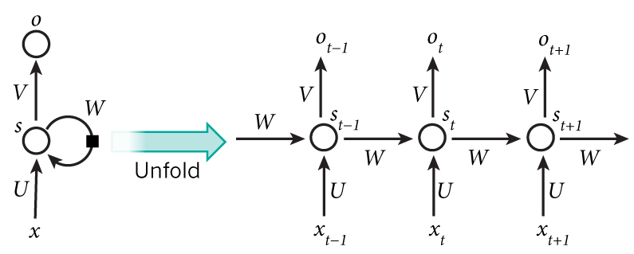

Figure 1: chain like structures in RNN (Image taken from analyticsvidhya.com)

As we can see in the below image, there are multiple layers like input, hidden and output layer. We can see there are two hidden layers. There is also a feedback loop from layer 2 to layer 1 of the hidden layer. This is the key difference where RNNs are differentiated from CNNs. There is no such kind of loops in CNN. Also, the

Figure 2: layers in RNN. (Image taken from course professor lecture materials)

RNNs are classified into types based on the architectures used in sequential learning. They are one to one, one to many, many to one, many to many. Also, Recurrent Neural Networks works bidirectional which makes them to learn in both ways.

To illustrate clear comparison between RNN and CNN networks, let’s take an example of two sentences – “Deep learning class is scheduled at 6PM Fridays”, “Every Friday at 6PM, deep learning class is scheduled”. If we give these two sentences as input to the RNN model and ask when the deep learning class is scheduled it gives ‘6PM’, it gets trained and produces similar results after trained on 2 sentences. While CNN model gives different results since they get learned layer by layer and have different weights assigned at each node at different layers. But in RNNs we have equal weights. This makes the clear applications of two distinguished kinds of neural networks.

Few examples include Recurrent networks that produce an output at each time step and have recurrent connections between hidden units. Recurrent networks with recurrent connections between hidden units, that read an entire sequence and then produce a single output. The size of the input and output of the RNNs models may vary based on the problem but CNNs have fixed sizes in the input and output layers. Recurrent neural networks work on the sequence or temporal data such as text or video They are useful in building the model to understand and train it about facial expressions, speech recognition, distinguished handwritings etc. while convolutional neural networks work on spatial datasets such as images to predict or classify the images based on the subject.

**Part 2**

**Provide an overview of the generative adversarial network and compare it with the convolutional neural network.**

Generative Adversarial Networks (GANs) are a kind of generative models introduced by Ian Goodfellow and other researchers in 2014 at University of Montreal. It is the most interesting idea in the last 10 years in the field of Machine Learning. Basically, GANs have two neural networks which are called as generators and discriminators. These pits one against the other. Generator is a model which generates data from random data.

GANs have larger capabilities. They can learn from any points of the data, and it can as be similar to human beings in any domains like images, documents, music, speech and arts. We can think GANs as robot artists. A portrait was sold for $ 432,000 which is generated by GAN. We can see image it below.



Figure 3. Source: skymind.ai

Discriminative algorithms are the models used to predict or classify the input data. In other way, discriminative algorithms map features to labels. While generative algorithms work in opposite manner of discriminative algorithms. They attempt to predict features for the label made by discriminative algorithms. For example, when you want to predict whether the image contains dog and cat. Discriminative algorithm will classify it as either dog or cat and generative algorithm predicts other features of the classified label i.e., dog. Moreover, discriminative models learn the boundary between classes and generative models learns the distribution of individual classes. GANs are the two-player game.

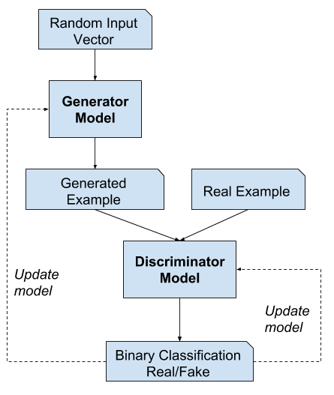

Figure 4: source – machinelearningmastery.com

In the above diagram we can get high level understanding of the GANs models. Discriminative model takes the input of real-world input and generated input. Here the generated input is an out from generative model. Generative model takes from random vector input and introduces features which resembles like real world data (mimicking). Discriminative model learns to distinguish between generated (fake) and read world data (correct) and classifies the subject.

Generative Adversarial Networks (GANs) have discriminative and generative approach while Convolutional neural networks (CNNs) have various convolutional and pooling layers and concluded with fully connected layer. GANs generally create and discern the data but CNNs are the feed forward neural networks using filters and pooling. GANs used to generate the objects that resembles like people in real however CNNs are like recognizing objects sounds and features of the subjects.

GANs are trained on the unsupervised learning approach which does not require labelled data. while CNNs are trained in supervised manner and requires labelling of the input to an output. GANs works as extracting and detracting the features from the object on the other hand, CNNs works to extract features from the objects.

**Reference:**

1. Singh, A. (2021, June 13). *Recurrent Neural Networks : Introduction for Beginners : Introduction for Beginners*. Analytics Vidhya. Retrieved October 5, 2023, from <https://www.analyticsvidhya.com/blog/2021/06/recurrent-neural-networks-introduction-for-beginners/>
2. Craig, L. (2023, August 8). *CNN vs. RNN: How are they different?* TechTarget. Retrieved October 5, 2023, from https://www.techtarget.com/searchenterpriseai/feature/CNN-vs-RNN-How-they-differ-and-where-they-overlap<https://machinelearningmastery.com/what-are-generative-adversarial-networks-gans/>
3. Brownlee, J. (2019, July 19). *A Gentle Introduction to Generative Adversarial Networks (GANs) - MachineLearningMastery.com*. Machine Learning Mastery. Retrieved October 5, 2023, from <https://machinelearningmastery.com/what-are-generative-adversarial-networks-gans/>
4. GoodFellow, I., Bengio, Y., & Courville, A. (2016). *Deep Learning*. Deep Learning. Retrieved October 5, 2023, from <https://www.deeplearningbook.org/>